# **A logo with a letter and a symbol Description automatically generated with medium confidenceSECD2613-05 SYSTEM ANALYSIS AND DESIGN**

# **PHASE 1: PROJECT PROPOSAL and PLANNING**

* Moaz Adil Abdugadir Jalal A23CS3025
* Ahmed Islam Mohamed Ezzeldin Abdelmohsen Kassem
* Sumaita Alam A23CS4056
* Loai Alqadasi A23EC9010
* Ahmed Ali Abdalla Musa A23CS4036

**1. Introduction**

As a bustling metropolis and economic hub in Malaysia, Johor Bahru relies heavily on its public transportation network to facilitate the mobility of its residents and workforce. However, navigating the city's bus system often presents challenges for commuters, particularly in predicting bus arrival times and minimizing wait times at bus stops. The inherent variability of traffic conditions, coupled with the lack of real-time information, exacerbates the uncertainty and inconvenience experienced by passengers as they plan their journeys across the city.

Therefore, this project aims to enhance the user experience and efficiency of public bus systems in Johor Bahru by introducing a real-time tracking system. Specifically, our objectives include reducing average waiting times, increasing ridership levels, and improving overall satisfaction among commuters.

**2. Organizational Background Study**

The public bus system in Johor Bahru is primarily operated by multiple bus companies under the oversight of the Land Public Transport Commission (SPAD) and the Iskandar Regional Development Authority (IRDA). The system comprises a network of routes covering various areas within the city and its surrounding suburbs. Key bus terminals and hubs, such as Larkin Sentral and JB Sentral, serve as central points for passenger transfers and intermodal connectivity.

multiple bus operators manage different routes and services. These operators range from large corporations to smaller, independent companies, each responsible for specific routes or geographic areas.

**2.1. Identified Problems**

During the background study on Johor Bahru's current public bus system Two significant issues were identified:

**Unreliable Schedule Adherence**

The lack of real-time tracking capabilities results in unreliable bus arrival times and schedules, exacerbating passenger uncertainty and frustration due to the absence of accurate information on bus locations and arrival times. This uncertainty contributes to longer wait times and missed connections, diminishing the overall user experience and efficiency of the public bus system in Johor Bahru.

**Inadequate Service Monitoring**

Due to the absence of real-time tracking capabilities, transportation authorities encounter significant challenges in effectively monitoring and managing bus services. The lack of real-time data on bus operations impedes authorities' ability to promptly identify service disruptions, address operational issues, and uphold service quality standards. Consequently, this limitation hinders the overall efficiency and reliability of the public bus system in Johor Bahru, compromising the quality of service provided to passengers and the system's ability to adapt to changing conditions.

**2.2. Improvement Opportunities**

The observation of the current system outlined Opportunities for system enhancement

**Congestion and Traffic Delays**

Addressing traffic congestion, especially during peak hours, is paramount to improving bus service reliability and reducing waiting times. Implementing real-time tracking systems can aid in dynamically adjusting bus routes and schedules to navigate around traffic bottlenecks, ultimately enhancing service efficiency.

**Infrastructure Constraints**

Improving infrastructure amenities such as bus shelters, signage, and digital displays can enhance the overall passenger experience and comfort while waiting for buses. Integrating technology solutions like smart bus stops equipped with real-time arrival information can mitigate uncertainty and provide commuters with timely updates on bus arrivals, contributing to a more seamless travel experience.

**Technological Integration Opportunities**

Leveraging technology solutions such as mobile applications and data analytics can significantly enhance the efficiency and effectiveness of public bus systems.

**2.3 Problem Statement**

The public bus system in Johor Bahru faces significant challenges that hinder its effectiveness in providing reliable, efficient, and user-friendly transportation services. Key issues include the lack of real-time tracking capabilities, resulting in unpredictable bus arrival times, inefficient route planning, and limited accessibility information for passengers and transportation authorities.

**3. Objectives**

**Reduce Waiting Times**

Minimize average waiting times at bus stops by enabling passengers to plan their journeys more effectively and by optimizing bus routes and schedules based on real-time data.

**Enhance User Experience and Increase Ridership**

Improve the overall experience for passengers by providing accurate and real-time information about bus locations and arrival times, reducing uncertainty and frustration associated with waiting for buses. Which will Attract more passengers to the public bus system ultimately increasing ridership levels and reducing reliance on private vehicles.

**Increase Efficiency** **and Optimize Operations**

Optimize the efficiency of bus operations by enabling transportation authorities to monitor and manage bus services in real-time, allowing for better resource allocation and scheduling.

**4. Proposed Solution**

To address the identified problems and capitalize on the improvement opportunities for the public bus system in Johor Bahru, the proposed solution involves the implementation of a comprehensive real-time tracking system integrated with modern technology solutions. The key components of the proposed solution are as follows:

**Real-Time Tracking System**

Develop and deploy a real-time tracking system that utilizes GPS technology to accurately monitor the location and movement of buses in real-time. This system will provide passengers and transportation authorities with up-to-date information on bus locations, arrival times, and service updates through various channels, including mobile applications, web portals, and digital displays at bus stops.

**Infrastructure Enhancement**

Improve infrastructure amenities such as bus shelters, signage, and digital displays at bus stops to enhance the overall passenger experience and comfort. Integrating technology solutions like smart bus stops equipped with real-time arrival information will provide commuters with timely updates on bus arrivals and contribute to a more seamless travel experience.

**5. Feasibility Study**

**5.1 Economical Feasibility**

Improving the bus system and user experience can result in several benefits, these benefits can be divided into Tangible and Intangible:

**Tangible Benefits**

1. **Increase the number of riders:** Enhancing the bus system's efficiency and user experience might motivate additional consumers to use the bus service, which will boost ticket revenue and sales.
2. **Reduce the operational cost**: Real-time monitoring of the system will help in optimizing bus routes which might result in reducing the operational costs of the bus service.
3. **Reduction in Waiting Time/Productivity Gain: With precise bus arrival information, passengers can plan efficiently, enhancing productivity. This improvement optimizes time usage, leading to increased productivity and better economic efficiency citywide.**

**Intangible Benefits**

1. **Enhanced User Experience**: Passengers appreciate accurate schedules, leading to higher satisfaction and loyalty.

Costs of the new system can be categorized into:

**Development Costs**

1. Hardware Acquisition: GPS devices, Communication equipment and LED digital displays.
2. Software development.
3. Staff training.

**Production Costs**

1. System maintenance.
2. Staff salaries.

**-**The Hardware cost is calculated for 60 busses and 20 bus stops; The number of busses is calculated based on the fact the total number of operating routes in Johor Bahru is 29 with an average of 2 busses operating in every route and the number of bus stops is based on the number of stops with largest number of riders.

**-**The assumed number of Johor Bahru bus users is 15000 passengers per day; the assumption is made by assuming that 1.4% of Johor Bahru population use public transport daily.

-The estimated base tickets sale revenue per year is 11250000rm.

**Cost Benefit Analysis (CBA)**









**As our Profitability Index 2.83 is more than 1 it means that our project is a good investment and feasible.**

**5.2 Technical Feasibility**

The required hardware technical resources (GPS devices and communication devices) for the new system are already available in the current system but a few adjustments would be needed for them to be compatible with the new system operations. The only required hardware that is not available in the current system is the LED displays, but they can be acquired.

The staff with the technical skills needed to achieve the required hardware adjustments and develop the new software are available within the organization.

Thus, the project is Technically feasible.

**6. Project Planning**

**Revolutionizing Commuter Experience**

Project Planning for Public Bus System Enhancement The enhancement of the Public Bus System is a critical endeavor aimed at mitigating issues pertaining to inaccurate appointments and unclear bus statuses. By integrating a GPS tracking system with bespoke software, the project aspires to furnish commuters with real-time bus locations and estimated arrival times, thereby amplifying user satisfaction and curtailing waiting durations.

**6.1 Human Resources**

Effective deployment of resources lies at the heart of project success. A strategic allocation of human resources is crucial, necessitating the inclusion of skilled professionals across various domains. Key personnel involved in the project include:

* **Project Manager**: Responsible for overall project oversight, coordination, and stakeholder management.
* **Software Developers:** Tasked with the development and implementation of custom software solutions tailored to the Public Bus System's requirements.
* **Hardware Engineers:** Engaged in the installation and configuration of GPS tracking systems and associated hardware components.
* **GPS Tracking System Experts:** Provide specialized knowledge and expertise in the deployment and operation of GPS tracking technology.
* **UI/UX Designers:** Design intuitive and user-friendly interfaces for the software application, enhancing user experience and accessibility.
* **Quality Assurance/Testers:** Conduct rigorous testing protocols to ensure the reliability, functionality, and performance of the implemented system.

Each team member plays a crucial role in their respective domains, contributing to the seamless integration and operation of the enhanced Public Bus System. Clear communication channels and protocols are established to facilitate effective collaboration and information exchange among team members, fostering a culture of accountability and excellence.

**6.2 Work Breakdown Structure (WBS)**

In delineating the Work Breakdown Structure (WBS), a comprehensive approach is adopted to systematically organize the project's intricacies. Beginning with the Project Initiation phase, tasks encompass defining project objectives and scope, assembling the project team, and crafting a comprehensive project charter to delineate project vision and objectives. Subsequent phases, including Requirement Analysis, Design, Development, Implementation, and Documentation, each entail a cascade of tasks meticulously designed to progress the project from conceptualization to fruition.

Within the Requirement Analysis phase, tasks revolve around collating user requirements, specifying data collection modalities, and identifying pertinent data sources essential for project success. Design endeavors encompass the development of user interfaces, database structures, and data collection mechanisms, supplemented by the formulation of plans for real-time monitoring features.

Development activities entail the actual construction of the user interface, implementation of monitoring features, and establishment of a robust database system. The subsequent Implementation phase encompasses user testing, training, and final implementation testing to ensure seamless integration and functionality. Finally, the Documentation phase involves project evaluation, lessons learned documentation, and the creation of comprehensive user manuals to facilitate system comprehension and utilization.

This structured approach ensures clarity, efficiency, and accountability throughout the project lifecycle, culminating in the enhancement of the Public Bus System to meet the evolving needs of commuters.

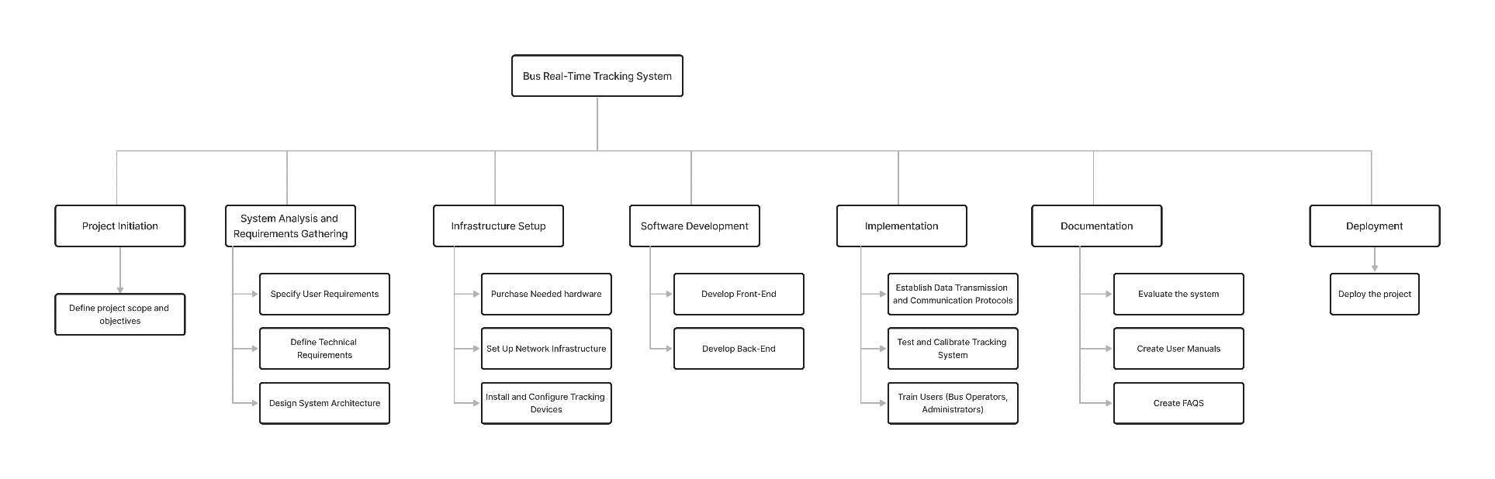

|  |  |  |  |
| --- | --- | --- | --- |
| **Task Description** | **Task Activity** | **Predecessor** | **Duration (days)** |
| Project Initiation | 1. Define project scope and objectives | - | 5 days |
| System Analysis and Requirements Gathering | 2. Specify User Requirements | 1 | 3 days |
| 3. Define Technical Requirements | 2 | 3 days |
| 4. Design System Architecture | 3 | 5 days |
| Infrastructure Setup | 5. Purchase Needed hardware | 4 | 3 days |
| 6. Set Up Network Infrastructure | 5 | 2 days |
| 7. Install and Configure Tracking Devices | 5 | 2 days |
| Software Development | 8. Develop Front-End | 4 | 7 days |
| 9. Develop Back-End | 4 | 10 days |
| **Implementation** | 10. Establish Data Transmission and Communication Protocols | 6, 7, 8, 9 | 5 days |
| 11. Test and Calibrate Tracking System | 10 | 2 days |
| 12. Train Users (Bus Operators,  Administrators) | 11 | 5 days |
| **Documentation** | 13. Evaluate the system | 12 | 2 days |
| 14. Create User Manuals | 12 | 2 days |
| 15. Create FAQS | 12 | 1 day |
| **Deployment** | 16. Deploy the project | 13, 14, 15 | 1 day |

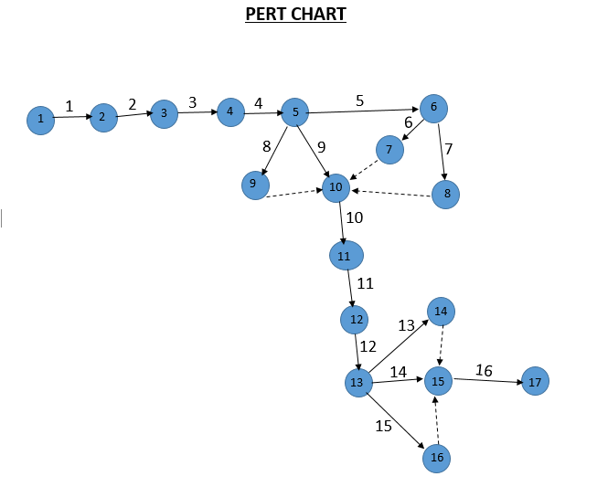**6.3 PERT Chart**

**6.4 Gantt chart**

|  |  |
| --- | --- |
| **Task Activity** | **Task Activity** |
| 1. Define project scope and objectives | 9. Develop Back-End |
| 2. Specify User Requirements | 10. Establish Data Transmission and Communication Protocols |
| 3. Define Technical Requirements | 11. Test and Calibrate Tracking System |
| 4. Design System Architecture | 12. Train Users (Bus Operators,  Administrators) |
| 5. Purchase Needed hardware | 13. Evaluate the system |
| 6. Set Up Network Infrastructure | 14. Create User Manuals |
| 7. Install and Configure Tracking Devices | 15. Create FAQS |
| 8. Develop Front-End | 16. Deploy the project |

**7. Benefit and Overall Summary of Proposed System**

The proposed real-time tracking system for Johor Bahru's public bus system aims to revolutionize commuter experience by addressing existing challenges such as unreliable schedules and inadequate service monitoring. By leveraging modern technology solutions, the project seeks to enhance user satisfaction, increase ridership levels, and optimize operations, ultimately improving the efficiency and reliability of public transportation in the city. The proposed project has a Profitability index larger than 1 which means it’s economically feasible and can be a real improvement to Johor Bahru’s public bus system.

**8. Project Management (Github)**

**8.1 Repository link:** [*https://github.com/MoazJalal/Group3_Project1_SAD_20232024*](https://github.com/MoazJalal/Group3_Project1_SAD_20232024)

**8.2 Repository Snapshot**

